Connor Bradt

**Task 1.1**

1.1A:

Under root privilege

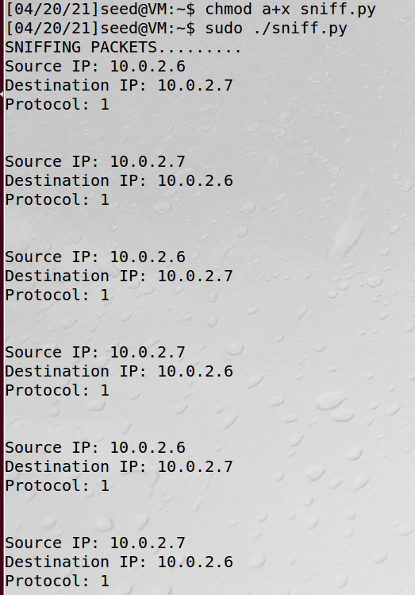

Without root privilege

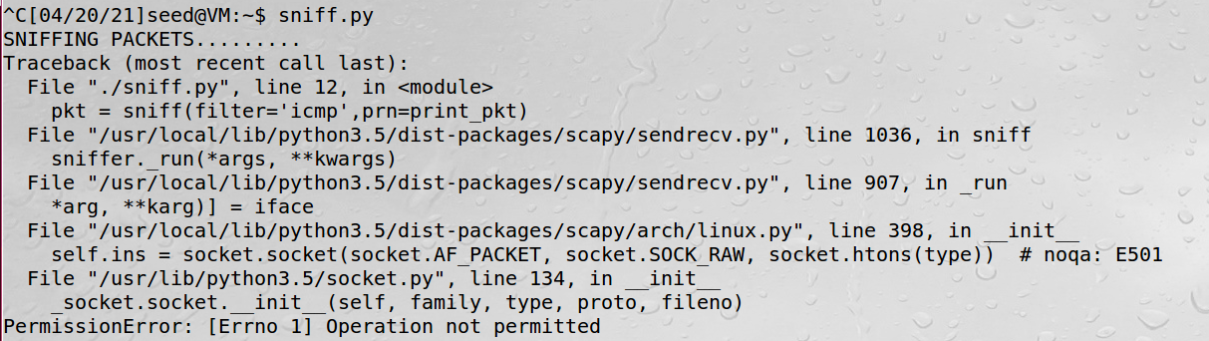

The system tried to trackback to when the script was executed under the root priviledge, but was denied execution because it did not have the required permission.

1.1B:

Only ICMP packets



TCP packets from IP address 10.0.2.6 port 23. Note: the port# is circled in blue

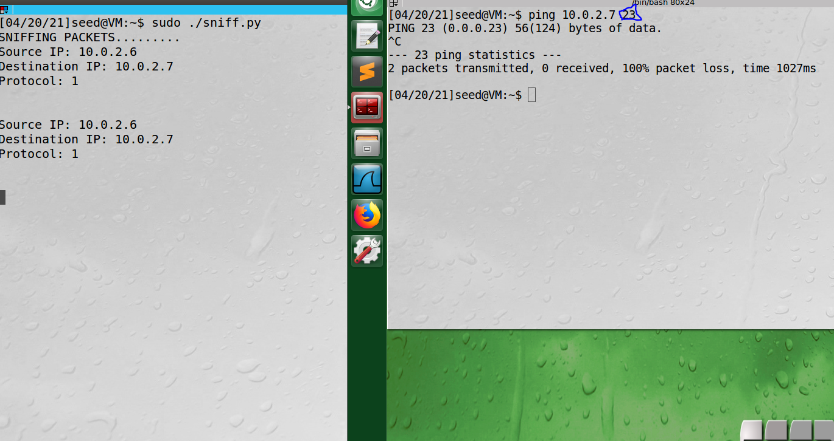

Subnet

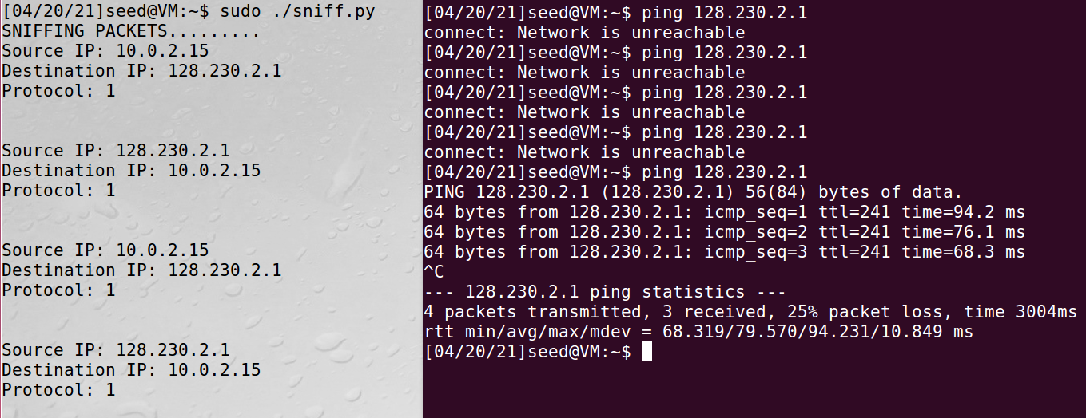

**Task 1.2**

ICMP packet spoofing code and header field attributes

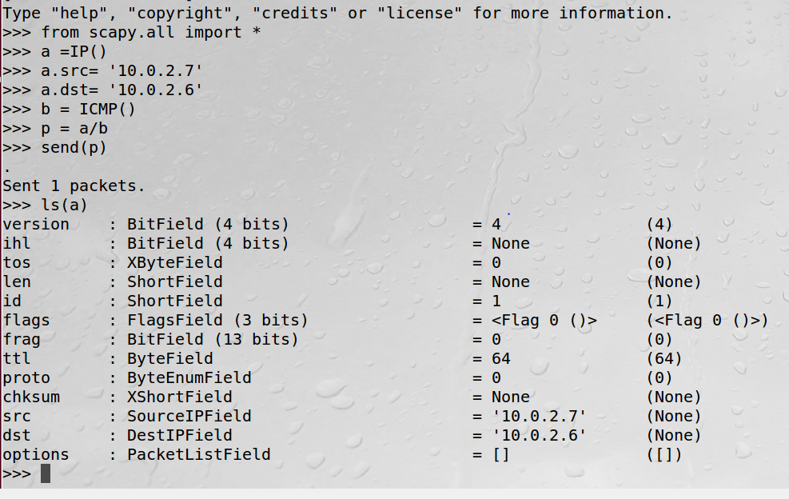

Wireshark proof of request acceptance by the receiver.

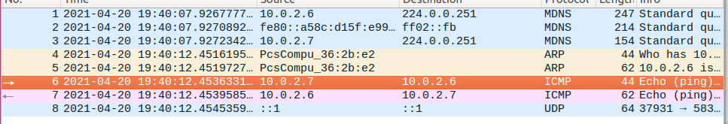

**Task 1.3**

pfw.edu IP address lookup.

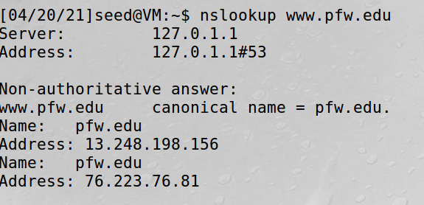

Wireshark confirmation of traceroute to pfw.edu IP address.

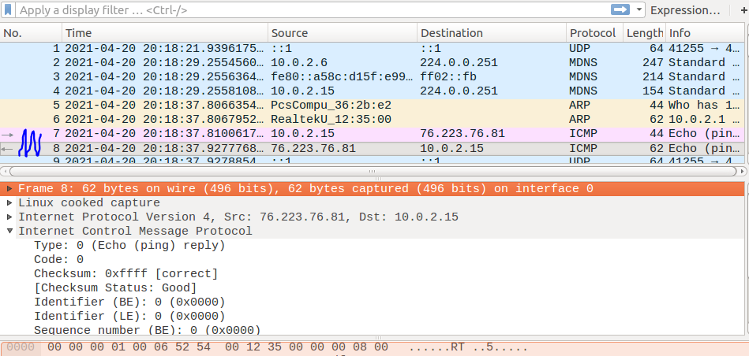

**Task 1.4**

Sniff and spoof A: Attacking, V: Victim. The Server is not running.

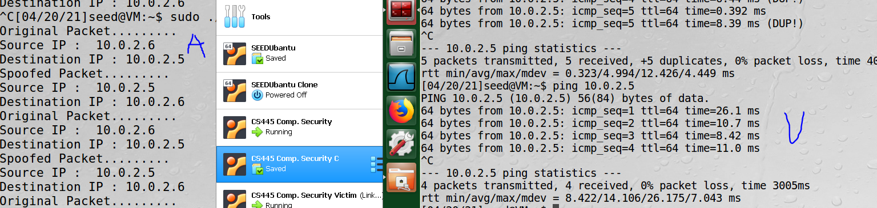

Git clone “repository URL”

Change directory(cd) to remote repository folder

Git remote add “name” “repository URL”

*create folder to copy the files to.

Change directory(cd ..) until home.

cp path/local_repo/src/* path/remote_repo/src ( easier to copy paths from home directory)

Change directory(cd) to remote repository folder

git rm --cached directory

git add directory (to avoid the git submodule issue. {may not be needed})

 git branch -r (to list all remote names for the remote repository)

git add local_repo/src/* (done in remote repository folder)

git commit –m “local files”

git push origin🡪(“remote name”) master

Try git fetch or **git pull** to get the extra report documents into the remote repository